Name: ____________________ IPad # __________

**TOPIC # 4**

**CHEMICAL BONDING**

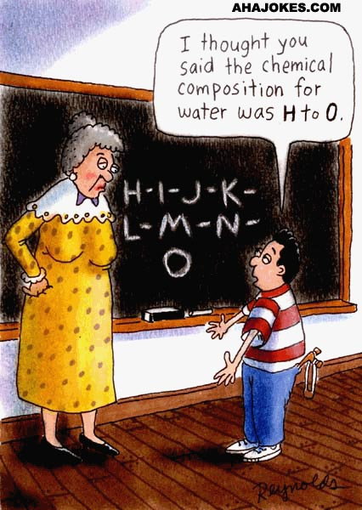

**Textbook Chapters 7 & 8**

**Homework Packet Due: ______________________**

**Exam Dates: Free Response: _____________________**

**Multiple Choice: _____________________**

**Looking Ahead:**

**Quarterly Exam- Free Response: __________________**

**Quarterly Exam- Multiple Choice: ________________**

**COMBINING ATOMS-CHEMICAL BONDING**

**STUDY GUIDE**

Understanding the types of bonds within a substance will help describe atoms and compounds in terms of physical and chemical properties.

* ***OCTET RULE*:** Atoms will lose gain, or share electrons in order to acquire a full set of eight valence electrons ( the stable electron configuration of a noble gas). ***Exception to the rule is Helium and Hydrogen.***
* **TYPES OF BONDING:**

|  |  |  |
| --- | --- | --- |
| **METALLIC** | **IONIC** | **COVALENT** |
| Attraction of a metallic cation for delocalized electrons  ***Metal with metal*** | Electrostatic force that holds oppositely charged particles together in a substance.  ***Metal with nonmetal*** | A chemical bond that results from the sharing of valence electrons.  ***Nonmetal with nonmetal*** |
| Properties:   1. good conductors of heat & electricity 2. malleable and ductile 3. luster | Properties:   1. Usually will have high melting point. 2. form very distinct 3-D   crystal shapes   1. generally hard and brittle 2. In the liquid state or when dissolved in water-can conduct electricity. | Properties:   1. Usually will have low melting point. 2. do not conduct electricity 3. In the solid state covalent compounds tend to be softer then ionic compounds. |
|  |  |  |

* **COVALENT BONDING CAN BE FURTHER CLASSIFIED.**
  + **POLARITY**: Electronegativity determines whether a molecule is either nonpolar or polar. ***Electronegativity*** is a measure of an atom's attraction for electrons in the covalent bond

***POLAR BOND***: When two atoms with different electronegativities are covalently bonded, the atom with the higher electronegativity will attract the shared electrons stronger than the atom with lower electronegativity.

***NONPOLAR BOND***: Two atoms are covalently bonded with similar electronegativities. There is equal sharing or pull of electrons.

**POLARITY OF A MOLECULE**

**POLAR MOLECULE NONPOLAR MOLECULE**

S N A P

**S**YMMETRICAL **N**ONPOLAR **A**SYMMETRICAL **P**OLAR

* + SINGLE (H2), DOUBLE (O2), AND TRIPLE (N2) BONDING
  + NETWORK SOLIDS…EXAMPLE DIAMOND AND QUARTZ
  + COORDINATE COVALENT BONDING

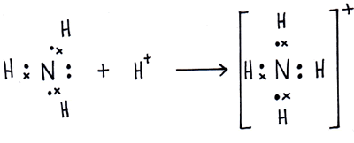

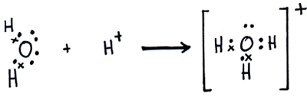

* + **INTERMOLECULAR FORCES OF ATTRACTION**

FORCES OF ATTRACTION EXIST BETWEEN MOLECULES. THESE FORCES ACCOUNT FOR THE EXISTENCE OF MOLECULAR SOLIDS AND LIQUIDS.

|  |  |  |  |
| --- | --- | --- | --- |
| **DIPOLE-DIPOLE** | HYDROGEN BONDING | LONDON DISPERSION  (VAN DER WAALS) | MOLECULE- ION |
| hclmoleculeforces | icehbonds |  |  |
| BETWEEN POLAR MOLECULES | HYDROGEN JUST WANT TO HAVE “FON” | BETWEEN NONPOLAR MOLECULES | BETWEEN IONIC AND POLAR MOLECULE |

**KEY TERMS:**

BOND ENERGY

IONIC BONDING AND IONIC CHARACTER

COVALENT BONDING AND MOLECULAR SUBSTANCES

SHAPES: LINEAR, BENT, PYRAMIDAL, AND TETRAHEDRAL

COORDINATE COVALENT BONDING

NETWORK SOLIDS

METALLIC BONDING

POLAR BOND AND NONPOLAR BOND

SINGLE BOND, DOUBLE BOND, TRIPLE BOND

LONE PAIR ELECTRONS

VALENCE SHELL ELECTRON PAIR REPULSION (VSEPR)

INTERMOLECULAR FORCES OF ATTRACTION: DIPOLE-DIPOLE, HYDROGEN BONDING, VAN DER WAALS (LONDON FORCES), AND MOLECULE-ION

***HOMEWORK PACKET***

**Part I-Ionic Bonding**

Using the glossary in your textbook, define ***ionic bonding***.

______________________________________________________________

______________________________________________________________

______________________________________________________________

**Page 199**

#2 ___________________________________________________________

#3 ___________________________________________________________

#4 Atoms of which elements tend to gain electrons? _____________

Atoms of which elements tend to lose electrons? _____________

#7 a. ________ b. _______ c. _______ d. __________

**Page 207**

#13 __________________________________________________________

__________________________________________________

__________________________________________________

#14 a. _________________

b. __________________

c. _________________

d. __________________

#16______________________________________________________________________

______________________________________________________________________

#17______________________________________________________________________

______________________________________________________________________

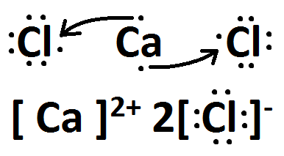#19 _________ & ______________

**PRACTICE DRAWING LEWIS DOT DIAGRAMS FOR IONIC COMPOUNDS**

|  |  |
| --- | --- |
| CHEMICAL FORMULA | LEWIS DOT STRUCTURE |
| **KCl** |  |
| **NaBr** |  |
| **MgBr2** |  |
| **AlF3** |  |
| **Ca3P2** |  |

**Part II-Metallic Bonding**

Using the glossary in your textbook, define ***metallic bonding***.

__________________________________________________________________________________________________________________________________________________________________________________________

**Page 212**

#20 ____________________________________________________________________

#22 Malleable: __________________________________________________

Ductile: __________________________________________________

#23 ____________________________________________________________________

__________________________________________________________

#25 Alloy: _____________________________________________________

Uses: _____________________________________________________

Alloy: _____________________________________________________

Uses: _____________________________________________________

**Review of Ionic and Metallic Bonding**

**Page 214-215**

# 41 ______________

#45 _____________________________________________________________________

___________________________________________________________

#46 _____________________________________________________________________

#51 _____________________________________________________________________

___________________________________________________________

___________________________________________________________

#63 a. _____________________ b. _____________________

b. _____________________ c. ______________________

**What did you observe?**

___________________________________________________________

**Page 216-217**

#70

a. _______________ c. _______________

b. _______________ d. _______________

#77 _____________________________________________________________________

___________________________________________________________

#84 _____________________________________________________________________

___________________________________________________________

#85

a. _____________ b. _____________

**Pearsons SuccessNet On-line**

Explore Cave Crystals by watching the video online.

Gypsum and Selenite are examples of ionic compounds having the same chemical formula. What makes them different?

**__________________________________________________________________________________________________________________________________**

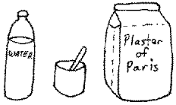

**Part III-Covalent Bonding**

Using the glossary in your textbook, define ***covalent bonding.***

__________________________________________________________________________________________________________________________________________________________________________________________

**Page 225**

#2 ______________________________________________________________________

____________________________________________________________

#5 _________________

**Page 238**

#12 _____________________________________________________________________

______________________________________________________________

#14 _____________________________________________________________________

___________________________________________________________

#15 _____________________________________________________________________

______________________________________________________________

#18 _____________________________________________________________________

**Page 246**

#22 _____________________________________________________________________

______________________________________________________________

**Page 253**

#31 _____________________________________________________________________

______________________________________________________________

#34 _____________________________________________________________________

______________________________________________________________

#36 _____________________________________________________________________

______________________________________________________________

#38 _____________________________________________________________________

______________________________________________________________

______________________________________________________________

**Page 256**

#43 _________________________________

#44__________________________________________________________________________________________________________________________________

#55____________________________________________________________________

______________________________________________________________

#56______________________________________________________________________

_________________________________________________________________________

#57 a. __________ b. ___________ c. ___________

**Page 257**

#68_________________________________________________________________________________________________________________________

#75 a. ___________________________________________________________________

__________________________________________________________________

b. ________________________

c. **Li &O** ____________ **N & O** ___________ **Mg & Cl** __________

**Page 258**

#81______________________________________________________________________

_________________________________________________________________________

#85______________________________________________________________________

_________________________________________________________________________

_________________________________________________________________________

**Pearsons SuccessNet On-line**

**Chapter 8 🡪8.2(Nature of Covalent Bonding) 🡪Kinetic Art (Covalent Bonds)**

**Observe the molecule building of H2, F2, H2O, NH3, and CH4 and answer questions online.**

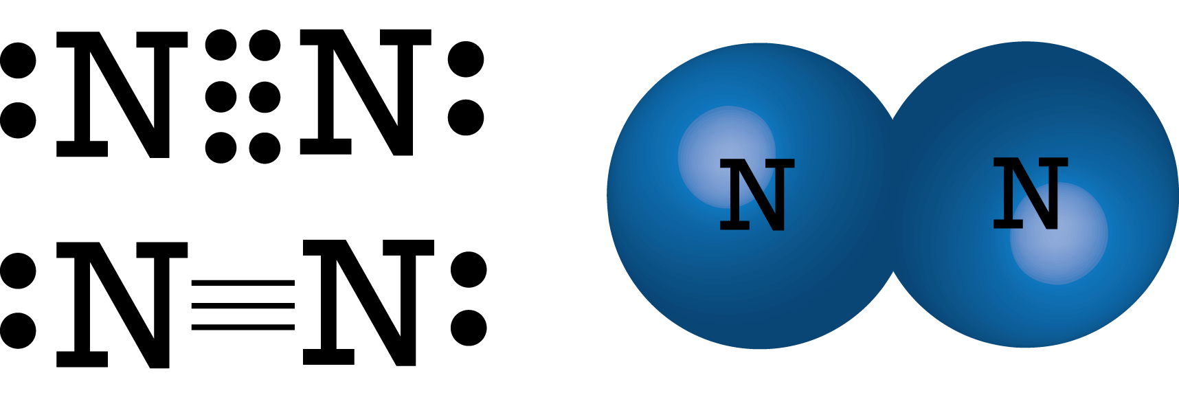

**PRACTICE DRAWING LEWIS DOT DIAGRAMS FOR MOLECULAR SUBSTANCES (COVALENT BONDING)**

***\*\*Please note that bond type refers to polarity of the bond between two atoms.***

***Molecule type refers to the polarity of the entire molecule (SNAP)***

***Shape of molecule …choose from linear, bent, tetrahedral, etc…***

|  |  |  |  |  |  |
| --- | --- | --- | --- | --- | --- |
| CHEMICAL  FROMULA | LEWIS DOT  STRUCTURE | STRUCTUAL  FORMULA | SHAPE OF  MOLECULE | POLARITY  BOND TYPE | POLARITY  MOLECULE  TYPE  (SNAP) |
| **Br2** |  |  |  |  |  |
| **HF** |  |  |  |  |  |
| **H2O** |  |  |  |  |  |
| **CF4** |  |  |  |  |  |
| **NH3** |  |  |  |  |  |
| **CO2** |  |  |  |  |  |
| **N2** |  |  |  |  |  |

**DO YOU KNOW THE DIFFERENCE?**

Using your textbook and notes from class complete the following table.

|  |  |
| --- | --- |
| TYPES OF SOLIDS | CHARACTERISTICS OF SOLIDS |
| Metallic  List 3 examples:   1. ____________ 2. ____________ 3. ____________ |  |
| Ionic  List 3 examples:   1. _____________ 2. _____________ 3. _____________ |  |
| Molecular  List 3 examples:   1. ______________ 2. ______________ 3. ______________ |  |
| Network  List 2 examples:   1. _______________ 2. _______________ |  |

**Part IV- Intermolecular Forces of Attraction (IMF’s)**

**Pearsons SuccessNet On-line**

**Go to Chapter 8 🡪 8.4 (Polar Bonds & Molecules) 🡪 Kinetic Art (Polar Molecules)**

**Understanding Intermolecular Forces of Attractions Between Polar Molecules**

**Answer the questions online after you have completed the activity**

Using your textbook and notes from class complete the following table.

|  |  |
| --- | --- |
| **IMF’S**  **INTERMOLECULAR FORCES OF ATTRACTION** | **CHARACTERISTICS** |
| **DIPOLE- DIPOLE**  **ILLUSTRATE AN EXAMPLE USING HBr** : |  |
| HYDROGEN BONDING  ILLUSTRATE AN EXAMPLE USING HF : |  |
| **VAN DER WAALS FORCES**  **(LONDON DISPERSION)**  **ILLUSTRATE AN EXAMPLE USING I2:** |  |
| MOLECULE-ION  ILLUSTRATE AN EXAMPLE USING KCl(aq) : |  |

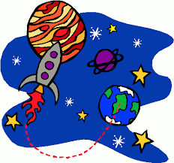**Chemical bond discovered that only exists in space**

July 2012 by Nicola Guttridge

There's a new bond in town, and this secret agent works best in extreme situations.

The bond, of the chemical variety, occurs in the presence of very strong magnetic fields, such as those found around ultra-dense white dwarf stars. Its discovery not only demonstrates the existence of an unfamiliar and exotic type of chemistry, it may also give insight into the behaviors of these mysterious stellar bodies.

White dwarfs are the remnant cores of low-mass stars that have exhausted all their fuel. They are thought to be the final state for most of the stars in our galaxy. Though they have masses comparable to that of our sun, white dwarfs only occupy the same amount of space as a small planet like Earth, making them incredibly dense.

They also exhibit super-strong magnetic fields on the order of 100,000 tesla – 10 billion times greater than Earth's magnetic field, and 10 million times greater than that of an average refrigerator magnet. This intense field can affect the behavior of the electrons that make up chemical bonds.

**Exclusion Principle**

On Earth, atoms usually bond either covalently, by sharing electrons with neighboring atoms, or ionically, via electrostatic attractions created by the transferal of electrons.

The Pauli exclusion principle governs the electrons that give rise to these bonds: two cannot occupy the same quantum state simultaneously. To avoid this scenario, electrons in bonds normally pair up in couples of opposing spin. But under the intense magnetic field of a white dwarf, "this spin interacts with the external field, acting like a little magnet," says lead author Kai Lange at the University of Oslo in Norway.

As a result, the spins of both electrons align with the external field, forcing one of the electrons to move into a different position known as an anti-bonding orbital. Normally, this would spell the end of any chemical bonds. "In a normal molecule these anti-bonding orbitals are not occupied by electrons," says Lange. "If they are occupied, the atoms are no longer bound together and the molecule breaks apart."

**Unfamiliar chemistry**

Lange and his colleagues wondered if things might be different around white dwarfs. "Chemistry and molecular physics become very different in the presence of a strong magnetic field," says Erik Tellgren, Lange's colleague. "Even very simple systems behave in exotic and unfamiliar ways compared to what we are used to under normal conditions."

With this in mind, the researchers used quantum chemical simulations to model chemical bonding in hydrogen and helium atoms in the magnetic field of a white dwarf. In both cases, the atoms were drawn into strongly bonded pairs.

Because the electrons in these bonded atoms occupied anti-bonding orbitals – which is forbidden in both types of known chemical bond – the researchers say this is a new type of bond. They have dubbed it "perpendicular paramagnetic bonding".

The work shows that "molecules that don't exist under normal conditions can exist in a sufficiently large magnetic field," says Lange.

David Clary of the University of Oxford, who was not involved in the study, called the research "excellent", adding "the results show that a magnetic field can stabilize molecules".

**Reading the stars**

Although the authors say that replicating the new bonds on Earth isn't feasible, the finding highlights how molecular chemistry may change in the presence of extreme conditions.

"I think there are probably other weird or unfamiliar types of bonding to be discovered," says Tellgren.

Such work will also help to further our knowledge of astrophysical objects like white dwarfs. By understanding how matter behaves around these objects, it may be possible to interpret their observed spectra more easily and accurately, and to better unravel what is happening in their atmospheres.

1) The new type of bond works under what type of conditions?

___________________________________________________________________________________________________________________________________________________________________________________________________

2) What does the intense magnetic field affect in the atom?

___________________________________________________________________________________________________________________________________________________________________________________________________

3) What happens normally, in an atom, when an electron enters an anti-bonding orbital?

___________________________________________________________________________________________________________________________________________________________________________________________________

4) Why did scientists use Hydrogen and Helium to simulate the bonding instead of another element?

___________________________________________________________________________________________________________________________________________________________________________________________________